

Year 10 Investigation 3

Name: ____SOLUTIONS______________________________________

Consecutive Numbers
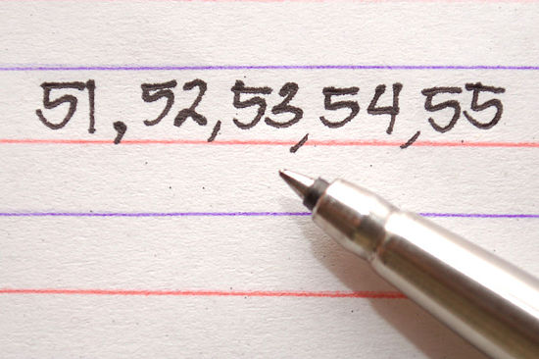

Total (47)

%

Progress

- 6 can be written as the sum of 3 consecutive whole numbers (6=1+2+3).
(Consecutive numbers follow one after another. They are next to each other in order.) Show all the possible ways you can write the numbers 2 to 16 as sums of consecutive whole numbers? Note: This will not be possible for all numbers. (14 marks)

2: Not possible
3: 1+2
Not necessary to have all possible combinations
1 mark per number for at least 1 correct way
4: Not possible
5: 2 + 3
6: 1+2+3
7:3 + 4
8: Not possible
9: 4+5, 2+3+4
10: 1 + 2 + 3 + 4
11: 5 + 6
12: 3 + 4 + 5
13: 6 + 7
14: 2 + 3 + 4 + 5
15: 7 + 8, 4 + 5 + 6, 1 + 2 + 3 + 4 + 5
16: Not possible

- Which of these numbers could not be written as the sum of consecutive whole numbers? (2 marks)
2, 4, 8, 16 (1 mark)
What sequence do these numbers represent?
2^{n}
or doubling previous term (1 mark)

- Pick any 6 pairs of consecutive whole numbers and make a list of their sums: (5 marks)

Numbers Sum
1. 1, 2 3
Examples only
1/2mark per ANY correct response
2. 2, 3 5
3. 3, 4 7
4. 4, 5 9
5. 5, 6 11
6. 6,7 13

- What do the sums have in common? (1 mark)
All are odd

- Using n and n+1 as your pair, prove your discovery in a) using algebra, given that 2n+1 must be an odd number. (1 mark)

n + (n + 1) = 2n + 1

2n must be even so when you add 1 it will always be odd

- Pick any 6 sets of 3 consecutive whole numbers and make a list of their sums: (7 marks)
Numbers Sum
1. 1, 2, 3, 6
Examples only
1/2mark per ANY correct response

2. 2, 3, 4, 9
3. 3, 4, 5 12
4. 4, 5, 6 15
5. 5, 6, 7 18
6. 6, 7, 8 21

- What do the sums have in common? (1 mark)
all are multiples of 3

- What is the connection between the middle number and the sum?
sum = middle number x 3 (1 mark)

- How could you calculate 107+108+109 without adding the numbers? (1 mark)
108 x 3

- If your 3 numbers are n, n+1 and n+2 then prove your discovery in a) using algebra (1 mark)
n + (n+1) + (n +2) = 3n + 3
= 3(n + 1)

as n +1 is the middle number, the sum is always the middle number x 3

- Pick any 6 sets of 4 consecutive numbers and list their sums and half their sums: (7 marks)
Numbers Sum Sum/2
1. 4 + 5 + 6 + 7 22 11
2. 1 + 2 + 3 + 4 10 5
Examples only
1 mark per ANY correct response
½ mark if not halved

3. 2 + 3 + 4 + 5 14 7
4. 3 + 4 + 5 + 6 18 9
5. 4 + 5 + 6 + 7 22 11
6. 5 + 6 + 7 + 8 26 13

- If you write the numbers as (n −1) + n + (n +1) + (n + 2), then what can you say about the numbers that can be written as the sum of 4 consecutive whole numbers, from the result of combining then factorising this expression? (1 mark)
(n – 1) + n + (n + 1) + (n + 2) = 4n + 2
= 2(2n + 1)
So the sum of 4 consecutive numbers will always be even

- What do you notice about the middle 2 numbers? (1 mark)
sum = double the sum of the middle 2 numbers

- Pick any 6 sets of 5 consecutive whole numbers and list their sums: (7 marks)
Numbers Sum
1. 1, 2, 3, 4, 5, 15
Examples only
1/2mark per ANY correct response

2. 2, 3, 4, 5, 6, 20
3. 3, 4, 5, 6, 7 25
4. 4, 5, 6, 7, 8 30
5. 5, 6, 7, 8, 9 35
6. 6, 7, 8, 9, 10 40

- What do the sums have in common? (1 mark)
all are multiples of 5

- What is the connection between the middle number and the sum?
sum = 5 x middle number (1 mark)

- How can you calculate 41+42+43+44+45 without adding the numbers? (1 mark)
43 x 5

- If your 5 numbers are n, n+1, n+2, n+3 and n+4 then prove your discovery in a) using algebra (1 mark)
n + (n + 1) + (n + 2) + (n + 3) + (n + 4) = 5n + 10
= 5(n + 2)
As n + 2 is the middle number, the sum will always be 5 x the middle number

- Starting with 3 + 4 ,
repeatedly add a consecutive integer to both ends. Repeat 5 times. (5 marks)
i.e. 3 + 4
2 + 3 + 4 + 5 (once)
1 mark per line
1 + 2 + 3 + 4 + 5 + 6
0 + 1 + 2 + 3 + 4 + 5 + 6 + 7
- 1 + 0 + 1 + 2 + 3 + 4 + 5 + 6 + 7 + 8
- 2 + - 1 + 0 + 1 + 2 + 3 + 4 + 5 + 6 + 7 + 8 + 9

Explain why the sums are always a multiple of 7. ( 1 mark)
We started with 7 and each time we add 7 to the total
eg 1 and 6, 0 and 7, -1 and 8
so the sum will always be a multiple of 7

